SOFTWARE REQUIREMENT ENGINEERING LAB
NAME: Muddasir Khan
S_ID: 15421
C_ID: 119005
TITLE: Class Diagram Code

CLASS DIAGRAM (PLACE & TRACK ORDERS):
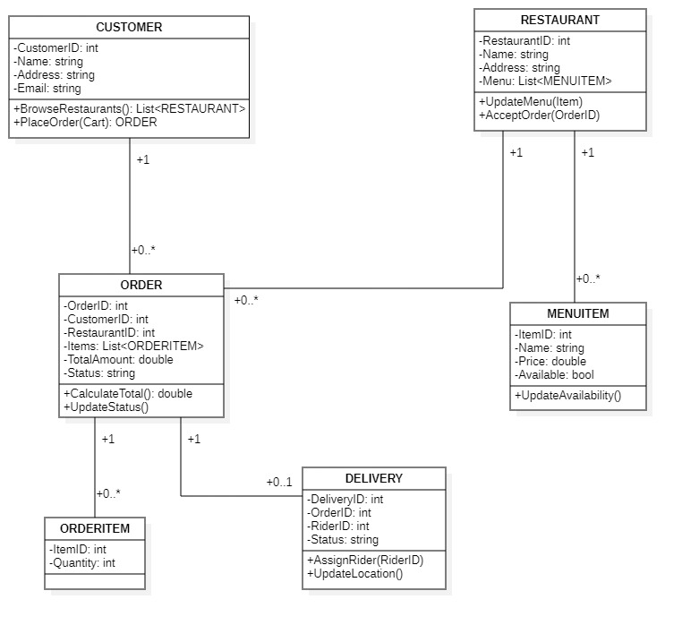

CLASS DIAGRAM CODE (PLACE & TRACK ORDERS):

using System;
using System.Collections.Generic;
using System.Linq;
using System.Text;

public class CUSTOMER {

public CUSTOMER() {
}

private int CustomerID;

private string Name;

private string Address;

private string Email;

public ORDER 0..*;

/// <summary>
/// @return
/// </summary>
public List<RESTAURANT> BrowseRestaurants() {
// TODO implement here
return null;
}

/// <summary>
/// @param Cart
/// @return
/// </summary>
public ORDER PlaceOrder(void Cart) {
// TODO implement here
return null;
}

}

using System;
using System.Collections.Generic;
using System.Linq;
using System.Text;

public class ORDER {

public ORDER() {
}

private int OrderID;

private int CustomerID;

private int RestaurantID;

private List<ORDERITEM> Items;

private double TotalAmount;

private string Status;

public CUSTOMER 1;

public RESTAURANT 1;

public ORDERITEM 0..*;

public DELIVERY 0..1;

/// <summary>
/// @return
/// </summary>
public double CalculateTotal() {
// TODO implement here
return 0.0D;
}

public void UpdateStatus() {
// TODO implement here
}

}

using System;
using System.Collections.Generic;
using System.Linq;
using System.Text;

public class RESTAURANT {

public RESTAURANT() {
}

private int RestaurantID;

private string Name;

private string Address;

private List<MENUITEM> Menu;

public ORDER 0..*;

public MENUITEM 0..*;

/// <summary>
/// @param Item
/// </summary>
public void UpdateMenu(void Item) {
// TODO implement here
}

/// <summary>
/// @param OrderID
/// </summary>
public void AcceptOrder(void OrderID) {
// TODO implement here
}

}

using System;
using System.Collections.Generic;
using System.Linq;
using System.Text;

public class MENUITEM {

public MENUITEM() {
}

private int ItemID;

private string Name;

private double Price;

private bool Available;

public RESTAURANT 1;

public void UpdateAvailability() {
// TODO implement here
}

}

using System;
using System.Collections.Generic;
using System.Linq;
using System.Text;

public class ORDERITEM {

public ORDERITEM() {
}

private int ItemID;

private int Quantity;

public ORDER 1;

}

using System;
using System.Collections.Generic;
using System.Linq;
using System.Text;

public class DELIVERY {

public DELIVERY() {
}

private int DeliveryID;

private int OrderID;

private int RiderID;

private string Status;

public ORDER 1;

/// <summary>
/// @param RiderID
/// </summary>
public void AssignRider(void RiderID) {
// TODO implement here
}

public void UpdateLocation() {
// TODO implement here
}

}

